**MEMO**

To: Buffalo County Board of Adjustments

From: Mike O’Connor

Re: Testimony OPPOSED to the R&J Rolling Acres mine application

Date: May 30, 2012

________________

I would like to update my previous testimony in opposition to the R&J application to include events that have occurred since those documents were written.

**TOPIC 1 – Highway safety**

Here is a very brief summary of the evaluation of Highway 88 by Clark Dietz Engineers prepared on April 18, 2012 and already submitted in public comments to the Board of Adjustments:

* **“Significant potential safety concerns exist with using this road for hundreds of additional heavy trucks per day.**
* **The roadway is in poor structural condition and appears to require frequent repairs due to several modes of failure under present day loading conditions. Accordingly, the rate of roadway deterioration and failure will increase as the intensity and frequency of the loading increases due to truck traffic.”**

**UPDATE**:

On 22-May 2012 an accident occurred on Highway 88 that highlights the reason for my concern about dramatically increasing the truck traffic on that road. I have several comments on that accident, followed by several photographs of the scene.

* The accident happened on a clear day, in good weather conditions. What happens on one of our famous winter days? Or during an ice storm?
* It happened in the middle of the day, so deer are far less likely to have been a factor in this accident. What happens when heavy trucks are using the road in early morning and evening twilight as is proposed in the application?
* It appears that there were no other vehicles involved in this accident. What happens when the frequency of trucks rises – and thus the odds that another truck or car is in the wrong place at the wrong time? Or a school bus?
* This accident happened on the “good” part of Highway 88 and it is my understanding that the driver was only shaken up. That might not have been the case if this accident happened up closer to Praag. In that case the truck could have fallen down a 20-foot embankment and the driver might not have been so fortunate. The “dugway” is much worse, with 100+ foot drops.
* Note the condition of the road in these pictures. This is typical along the whole route and is the reason why Clark Dietz Engineers is concerned about rapid deterioration of the road.

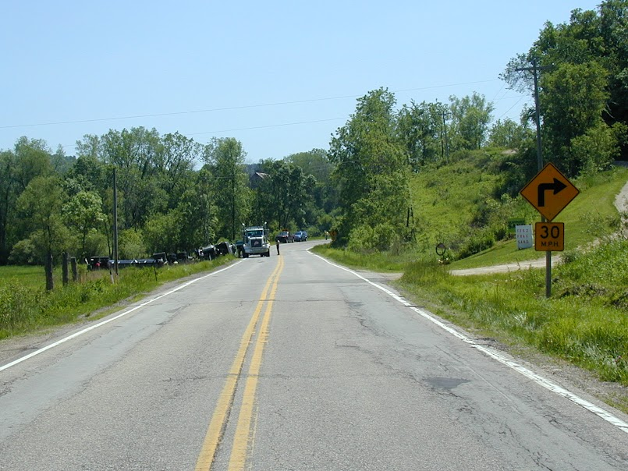

Photo credits – Gary LeMasters – Yaeger Valley Road

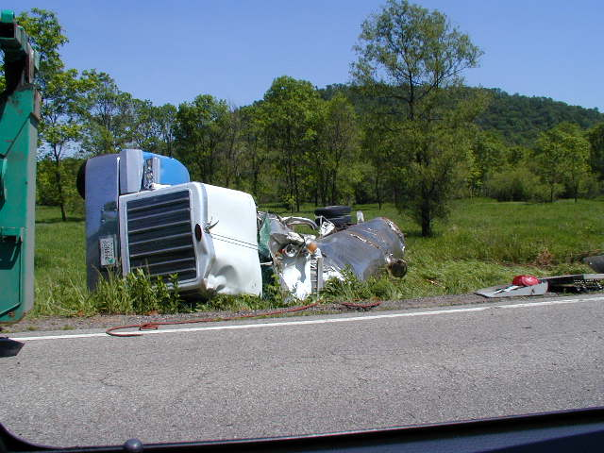

**TOPIC TWO – Traffic Volume on WI 88**

It has also come to my attention that there was testimony to the effect that Highway 88 currently sees something on the order of 800-1000 vehicles a day. I believe that to be in error, at least on the segment of Highway 88 being proposed as the haul route for this mine.

Here is an excerpt from a 2009 traffic study, which shows that traffic volume **at the mine location and south along the proposed haul route** to be considerably lower than that. The two relevant numbers are the 260 vehicles/day recorded just north of the mine location and the 180 vehicles/day just south of the mine location (at the junction of WI 88 and County T).



**Observations**:

* These numbers record the number of vehicles per day. Those of us that live on this segment of WI 88 can assure you that heavy trucks such as the ones proposed by R&J Mines comprise no more than 10% of the traffic on any given day. So a reasonable working estimate is that no more than 10-30 heavy trucks per day are traveling the northern portion of the proposed haul route. My neighbors will probably argue that I’m estimating on the high side, but I want to use a conservative number for the calculation that follows.
* This means that R&J is proposing to add roughly 300 heavy truck trips/day to a road that is currently seeing 30 or less – conservatively, a tenfold increase and perhaps as much as a 30-times increase.
* A tenfold increase to the number of heavy trucks on this sub-standard road could lead to several pretty bad outcomes:
  + Dramatically higher odds of an accident
  + Dramatically higher wear and tear on the road

I hate to beat a dead horse, but this seems like a really bad idea.

**TOPIC THREE – DOT Highway Study Is Not Complete**

I have been in contact with Tom Beekman of the DOT and he informs me that as of today (30-May, 2012) their study of Highway 88 is not complete.

It was my understanding that the R&J mine application was tabled in order to obtain the results of this study. Given the “two week rule” that the County has imposed on citizens who wish to submit written testimony, it’s impossible for me to offer comments on that work – except to raise the question as to why the meeting was scheduled in such a way that the study, if it’s available at all, can’t be reviewed by the public before the written-comment deadline.

**TOPIC FOUR – Regional Economic Impact**

In response to the proponents of the “Sand equals jobs” argument I would like to draw your attention to a recently completed UW Extension study ("Frac Sand Mining and Community Development") that was released in May of 2012. This study raises many of the same questions that I’ve raised in previous testimony. Here is a link to the full study:

<http://www.aae.wisc.edu/pubs/sps/pdf/stpap565.pdf>

Here is a summary of the conclusions of that study (bold highlighting is mine).

* **Mining, as an industry within the U.S., remains inherently unstable through the “flickering effect”** but the level of instability seems to be declining over time.
* The growing pool of “resource curse” literature suggests that **robust economic growth and development from resource extraction activities should be considered the exception rather than a general rule**.
* **Communities that are more heavily dependent on mining for employment tend to experience greater negative impacts after the mines close than positive impacts while the mines are in operation.**
* One must guard against making blanket generalizations about the impact of mining on the local community. In many ways mining can provide well-paying jobs leading to lower levels of poverty. But on the other hand, **mining activity appears to be associated with poorer overall health levels within the community.**
* For remote rural counties we have weak evidence that counties more heavily dependent on mining for employment will tend to have a slower population growth rate. There is more consistent evidence that mining has a positive impact on employment and income growth rates.

And here is a series of questions that they pose as “issues to consider” in their study. I think that it is a very bad idea to approve mines such as the one proposed by R&J Rolling Acres until we have good answers to these questions.

* **Are mining operations consistent with other sources of economic activity within the region?**

I would submit that the answer to this question might well be “no” when it comes to the recreation and tourism that comprises a substantial portion of the County economy. Indeed the Buffalo County web site home page greets the first time visitor with a description of the area that highlights this scenic recreational aspect of the County economy:

“Buffalo County will astound you with scenery unsurpassed by any other County in Wisconsin. Buffalo County offers beautiful valleys of unsurpassed fertility, bordered by towering bluffs on all sides, which in the summer when covered in foliage, offer a view of scenery rarely equaled.”

* **Is the public infrastructure (transportation networks) sufficient to support the mining operations?**

I will not bother you with a repeat of the arguments made in previous testimony except to say “no, not in my opinion.”

* **Are sufficient public resources (i.e., tax revenues) available to maintain infrastructure in the face of increased deterioration through usage?**

This seems to me to be a crucial issue for you to consider when making your decision. The proposed haul route traverses something over 20 miles of Highway 88 alone. As noted earlier, the road is deteriorating under its current load, which on the “Praag dugway” segment is currently on the order of 10 to 30 heavy trucks a day according to the 2009 data shown above. Given that this application proposes to increase the number of heavy trucks by a factor of 10, this road is likely to require substantial repairs, very soon.

Who will pay for those repairs?

This then is another reason to deny this application. We need time to develop “model conditions” on mines like this that require them to pay for road damage rather than laying that burden on County taxpayers. This is over and above the overriding safety issue of running hundreds of heavy trucks on a road that is sub-standard from a design standpoint.

* **Is there a sufficient pool of labor to meet the needs of the mining operations and replace workers who transfer into the mining industry?**

The BOA is supposed to evaluate the health, safety and welfare of the whole County when making decisions. If the answer to this question were “no, there isn’t sufficient labor to meet the needs of mining operations” then I would submit that the “mining equals jobs” argument is disingenuous.

* **Is the community making adequate investments to build on the economic activity generated by mining operations?**

The UW Extension study suggests that when mining is introduced without these investments, the net impact on the County is to reduce economic growth.

Clearly at a minimum we need to understand how to protect the recreational and tourist segments of the County economy from the impact of mines such as this. Otherwise we may be running the risk of losing more jobs than we gain.

* **Is the community implementing strategies to adjust to mine closures? In other words, are post-mine plans in place and being acted upon?**

“Post-mine plans” are another crucial dimension of this decision. Another reason to deny this application is to give the community time to develop “model conditions” that ensure that the conditions placed on operations like the R&J operation are sufficient to handle the situation after the mine (inevitably) closes. The community also needs to make sure that those “model conditions” are drafted in a way that they remain binding after a thinly capitalized promoter “flips” the mine to a different operator.

* **Is the community learning from the experiences of other communities that have experienced this type of development?**

Here again the UW Extension presents a reason why I oppose this mine application. We haven’t had time as a community to understand how to manage the public-policy tradeoffs that these mines present.

For all of these reasons, plus the many more that I’ve described in several rounds of previous testimony, I ask that you reaffirm your earlier decision to deny this application.

Mike O’Connor

Box 38

Gilmanton, WI 54743

[Mike@haven2.com](mailto:Mike@haven2.com)